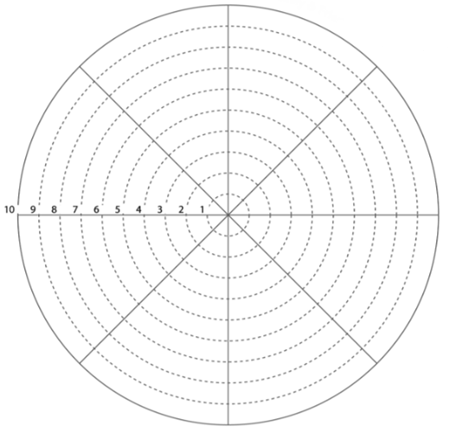

**DIRECTIONS:** Rate your satisfaction in each dimension on a scale from 1-10 (10 being most satisfied) and color in section accordingly. Ask yourself questions like: Do I neglect this section on a regular basis? Do I spend adequate time on this dimension? Do I feel fulfilled in this area?

WELLNESS WHEEL

FINANCIAL

INTELLECTUAL

OCCUPATIONAL

PHYSICAL

SOCIAL

EMOTIONAL

SPIRITUAL

ENVIROMENTAL